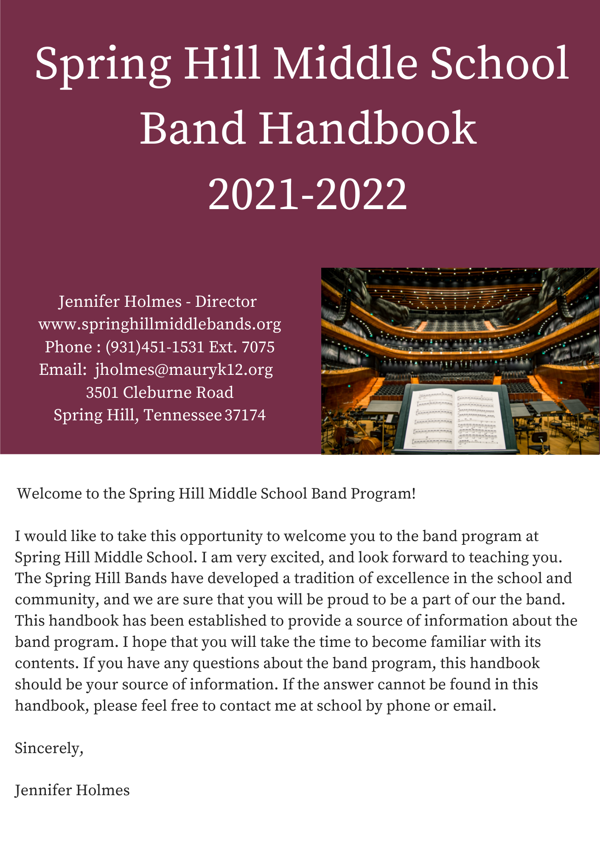

SHMS Generals Band Calendar
2021-2022
Date | Event | Time
Saturday 8/14 SHHS Band Room | Beginner Instrument Fitting and Pick-Up | Families will sign up for time slots. 10:00-2:00- High School Band Room
9/14  PT Conf. Night | Booster Meeting  All Parent Informational Meeting | 6:00 PM
8/26 | Home Football Game Pep Band for available 7th and 8th grade Band Students | 6:00-Game Starts, 5:30-Arrival to Band Room
9/9 | Home Football Game Pep Band for available 7th and 8th grade Band Students | 6:00-Game Starts, 5:30-Arrival to Band Room
9/23 | Homecoming Football Game Pep Band for available 7th and 8th grade Band Students | 6:00-Game Starts, 5:30-Arrival to Band Room
10/19 | Fall Concert Dress Rehearsal (7th & 8th only) | 3:00-4:00
10/22 | Fall Concert | 6:30 Auditorium
Fall Fundraiser | Laundry Mama Fundraiser  All Students Need to Participate  This is our main funding source for the year.
10/29 | 8th Grade Night with the SHHS Band at Football Game | TBA
TBA | Deadline for all Mid-state Participant Registration | $10 registration fee  Only for 7th and 8th Grade
11/6 | Mid-State Prep Clinic | Time TBA-Whitthorne M.S.
TBA | Parade Practice | 3:00-5:00
12/7 | Dress Rehearsal - All Grades  Winter Concert | 3:00-5:00
12/9 | Winter Concert - All Grades | 6:30  5:30 Call time
12/11 | Mid-State Auditions -Only for 7th and 8th Grade | Will register for time slot
12/11-Saturday | Spring Hill Christmas Parade as one mass Spring Hill Band! (SHMS, BCMS, SHHS) | TBA
1/6-1/8 | Mid-State Honor Band Clinics (students who make it) | Murfreesboro, TN
1/27-1/28 | Maury County Honor Band (Selected Students) | Columbia Central/Whitthorne
3/3 Tentative | Concert Performance Assessment Preview Concert  7th and 8th grade only  This concert includes the entire Spring Hill Band Program (SHMS, BCMS, SHHS). | TBA-evening
3/7-3/11  Exact date TBA | MTSBOA Concert Performance Assessment  (7th and 8th grade only) | During school  MTSU
3/19 | Maury County Solo and Ensemble (Any Band Student) | EA Cox Middle School
TBA | Whitthorne Jazz Festival- Jazz Band will perform | TBA
TBA | 7th & 8th Grade Dress Rehearsal  Dollywood | 3:00-5:00
5/5-5/6 | Dollywood  7th and 8th Grade Concert Festival Trip | Leave SHMS after school on Thursday and we return at 9:00p.m. on Friday.
5/10 | Dress Rehearsal for  Spring Concert (All Grades) | 3:00-5:00
5/13 | Spring Concert (All Grades) | 6:30 SHMS Auditorium  (5:30 Call Time)

2021/2022
- This is a tentative schedule for the year, and dates are subject to change. Please mark all dates on your calendar and let me know of any conflicts, a.s.a.p.
- There may be extra section rehearsals scheduled after school on an as needed basis.

ACTIVITY INFORMATION
Fall Symphony Field Trip: I am still planning towards a musical field trip of some sort this fall; however, it may not be to the symphony. They are just now getting up and going again and do not have many educational trips available at the moment.

Concert Dress Rehearsals: These required rehearsals are from 3:00-5:00 and usually happen the week of the concert on Tuesday or Thursday. Students do not need to wear their concert attire, but are expected to stay for the entire time. Parents, who are unable to attend the concert, may sit in on our dress rehearsals.

Concerts: Concerts are a huge part of your child’s experience. It is as if the concert is their final test of the concepts they have been learning. All students are expected in the band room, with their instruments out by the announced call time and all concerts start at 6:30p.m. Parents may come with their students; however, the auditorium doors will not open for seating until approximately 15 minutes before the concert begins. Students are also expected to stay throughout the entire performance.

Solo and Ensemble: This is a volunteer event, highly encouraged, and is open to all band students. However, students will receive at least one ensemble grade each semester. Students who participate in the festival will receive an automatic A. Maury County will host one of these festivals in the spring at E.A. Cox Middle. MTSBOA will host others across Middle TN throughout the year. The cost is $7 to register, and your student must find their own ride to and from the competition. The students will work with the band director to find appropriate music.

Spring Hill Christmas Parade: This event is open to all grades. This year we plan to perform again as one mass Spring Hill Band combining with SHHS and BCMS. We will all practice together Saturday afternoon before the parade. We will also have one practice after school from 3-5 before the event. Students are responsible for their own ride to the high school where we will bus them to the parade route.

MTSBOA Mid-State Auditions: Mid-state is a highly competitive event that auditions 7th and 8th grade students from all over the mid-state to create two exceptional bands that get to perform together in January. It determines the best of the best in Middle Tennessee. It is a wonderful opportunity for all students and a highly recommended experience. All 7th and 8th graders will be tested on the music requirements in class and will be encouraged to participate. The audition is an all- day event. Students are required to find their own transportation and are free to leave once their audition is complete.

Laundry Mama Fundraiser: This is our biggest fundraiser of the year without it we would have to charge much larger band fees. All band students sell laundry/dish detergent in bulk for a great bargain to the consumer and 40% profit for the Band Boosters. Donations are accepted for those who choose not to participate.

MTSBOA Concert Performance Assessment: This is a sight-reading and performance festival and assessment that both the 7th and 8th grade bands will attend. At this festival the bands will be adjudicated by several judges, not just on their prepared pieces, but also in sight-reading. This event happens during the school day at MTSU.

Maury County Honor Band: Is comprised of 7th and 8th graders from all over Maury County and will meet for a weekend in Early Spring to conduct a clinic and concert. Students are chosen for this band by each band director based on their performance throughout the year. "Mid-state auditionees will be given attendance priority in the All County Bands. Other students will be added at the directors' discretion." They do not have to make mid-state; they just need to have auditioned.

Dollywood: All 7th and 8th graders will be invited to attend the Trills and Thrills Music Festival in Pigeon Forge in May. They will perform for judges in the morning and will then spend the rest of the day at the Dollywood Theme park. This is an overnight trip and students will have to meet certain requirements to attend the trip.

General’s Pep Band: This ensemble is open to all 7th and 8th Grade Band students who commit to playing in the stands at the three football home games. Students will need to have a flip-chart and liar specific to their instrument.

Jazz Band: Jazz Band begins in January. This band will perform in the Whitthorne Jazz Festival in April. Rehearsal times are TBA.

COMMUNICATION

A key element of a successful band program is communication.

Email: This is a primary method of communication used for the band. E-mails will be used for providing updates about assignments, tests, concert dates, band booster news, and general information about the band program. E-mail addresses will remain hidden for privacy. Please fill out the following google contact form to make sure you get put on the list:

Web site: Now all our communication can be found in one place! Our address is: https://www.springhillmiddlebands.org

Google Classroom: Each of my band classes have their own google classroom. This is where all of their written assignments (ex. Listening Journals) and many resources will be posted for the students. If you are ever concerned about your child’s grade, ask them to see google classroom assignments. If you still have questions, feel free to reach out!

We use the app Remind specifically for off campus trips like Dollywood in May. I will set up a code specifically for this trip. Please be advised that the best way to speak to the band director with questions or concerns about the band class is through email or voicemail.

THE GENERALS BAND OATH AND EXPECTATIONS

- “We are confident and passionate musicians, who put 100% effort into all that we do.”

- “We put our band before ourselves, by encouraging others to succeed. We listen, we share, and we care.”

- “We show up on time, with energy, and with amazing attitudes.”

- “We take care of our instruments and keep them in good working condition, by cleaning them often, putting them together and away with care, and by not allowing others to play them.”

- “We take pride in our band room, by keeping it free of food, drinks, gum, and trash. We are aware of our surroundings and clean up after ourselves and others without being asked. We keep our lockers and cases clean.”

- “We are mentally strong and try to improve every day, by setting personal goals and practicing to meet those goals.”

ATTENDANCE

Good attendance is vitally important to any team activity. In band we all depend on each other to be successful, each member is equally as important.

Attendance for all concerts and rehearsals is absolutely mandatory. Concerts are like the final test, on all that we have learned in class, and dress rehearsals are like our final study session for that test. Your child will receive a test grade for these events.

Unexcused absences: "I could not find a ride," "I forgot," "No-Show,” “Birthday Party,” “Family is in town,” Grades missed because of unexcused absences will not be allowed to be made up.

Excused absences: Death in the family, extreme sickness, real family emergencies. If you are aware of a conflict with any of the concert dates now, please email the band director with a description as soon as you are aware of a conflict. If the absence is sudden and unexpected, please email the band director when it is feasible to do so, no later than the student returning to school, and they will be given make up work. Ms. Holmes will work with coaches for all school sports related conflicts, as these are excused as well.

GRADES:

60% Summative:
- Concerts
- Listening Journals
- Playing Exams
- Dress Rehearsals
- Performances
- Dictations

40% Formative:
- Classroom assignments and homework
- Class Participation
Students receive 5pts a day for class participation. They receive these points for preparedness, having their music, instrument, pencil, book, journal, and for playing when asked. Students lose points in this area for not having all class materials, excessive talking, and failing to meet the classroom expectations.

LISTENING JOURNALS

We know that the common denominator among great musicians is that they listen to music. To encourage listening in young musicians, we have incorporated listening journals. Students should have a notebook or journal in their band binder. Once a week we will listen to a piece of music in class, students will be asked to journal about what they hear. In addition, students will have approximately two journal assignments each quarter to add to their journal along with in class reflections and smart goals. You can find Listening Journal assignments in Google Classroom and specific details on the band’s website.

FIELD TRIP REQUIREMENTS

For your student to be allowed to go on out of school field trips they must.

- No more than 3 unexcused absences from school within each 9 week-period.
- No incomplete classwork.
- No ISAS within the current 9 week-period
- No OSS for the entire school year.
- Must be passing all subjects
- No outstanding fees.
- Must sign the SHMS fieldtrip agreement.
- Must turn in permission slip.

MATERIALS and FEES
The fee to be in the Spring Hill Middle School Band is $35 and should be paid along with any other school fees at the beginning of the semester. This money will pay for books, music, and the student’s band polo.

Each student will also be responsible for the purchase or rental of their own instruments. For larger and more expensive instruments, i.e. (tuba, euphonium, baritone saxophone, oboe, and bassoon), students will rent school owned instruments. School owned instruments cost $45 dollars a year and instruments are rented on a first come first serve basis.

(Band should be available to all students, if instruments or fees are an issue, please speak to me individually, and we can discuss booster sponsorship options, and other ways to still give your child this amazing experience.)

Each student will need the following materials for class:
Assigned student device (chromebook)
2 working pencils
1" 3-ring binder with page protectors for music and hand outs
Some loose paper or small spiral

Concert Dress  Black Dress Pants or Skirts (Skirts must cover the knees when sitting down)  Black Socks  Black Dress Shoes (No Tennis Shoes)  Band Polo (Will Be Provided) | General Pep Dress and Materials  Khaki Pants or Shorts  Tennis Shoes  Band Polo (from previous year)  Flip Chart  Liar for specific instrument | Jazz Band Dress and Materials  Black Dress Pants  Black Dress Shirts or Polo  Black Socks and Dress Shoes

PRIVATE LESSONS
The directors will always strive to give as much individual attention to each student, but between time constraints and size of the band program, the directors do not always reach each individual student as often as needed. Private lessons make a BIG difference for the advanced student and the struggling student. While it is not required to take private lessons to be part of the band program at Spring Hill Middle School, it is highly recommended.

The Band Directors will have a list of private teachers and will provide names and information to parents upon request. Some instruments may have after school lessons available from instructors who come to the school.

SMART Music
Maury County schools will once again be providing each band student with a full subscription to Smart Music this coming school year! Smart Music provides students an opportunity to play in real time with a computer program designed to help them grow as a musician. All playing tests will be submitted in Smart Music. If you are concerned about your child’s grade, consider asking them to view their assignments in Smart Music.

EQUIPMENT

Having the right equipment can make a big difference in the success or failure of a music student! Please avoid purchasing your instrument from online resources or non-music shops like Walmart. Non-branded instruments are sometimes refused at repair shops and will not last. Without good reeds, oil, or sticks a student cannot play up to his/her potential. In some cases, having the necessary supplies can affect the life or death of a musical instrument!!! Protect your investment.

The following is a list of all REQUIRED accessories that the student will need for their instrument.

WOODWINDS: | BRASS:
FLUTE:  Cleaning/Tuning rod,  Cleaning cloth | Trumpets, Euphoniums, Tubas  Valve oil;  Tuning slide grease,  Cleaning snake,  Mouthpiece brush  Polishing cloth  Spit collecting Cloth  Euphonium suggested mouthpiece: Bach 6 ½ AL  Tuba suggested mouthpiece: Conn Helleberg
CLARINET:  Swab,  Cork grease,  Extra reeds VANDOREN (Strength 2 or 2½ for 6th graders, and Strength 2½ or 3 for 7th and 8th graders),  Reed guards (You should rotate between at least 4 working reeds and change them every 2-3 weeks.) | French Horns –  Rotary oil;  Tuning slide grease,  Cleaning snake,  Mouthpiece brush  Polishing Cloth  Spit collecting cloth  Suggested Mouthpiece:  Holton Farkas Medium Deep Cup
SAXOPHONE:  Swab,  Cork grease,  Neck plug,  Extra reeds VANDOREN (Strength 2 or 2½ for 6th graders and Strength 2½ or 3 for 7th & 8th graders),  Reed guards (You should rotate between at least 4 working reeds.)  Tenor Sax Suggested Mouthpiece:  Selmer C * (star): will last through high school  Yamaha 4C | Trombones -  Slide CREAM (Trombotine recommended)  Tuning slide grease  Cleaning snake  Mouthpiece brush  Polishing Cloth  Spit collecting cloth
Percussion:
Drum Pad (Reel Feel/ Xymox)
Mallet bag
Concert Snare Sticks
Bell mallets (hard plastic)
Timpani mallets (medium soft)
Yarn Mallets (medium soft)

HIGHLY RECOMMENDED ACCESSORIES:
(Not Mandatory)
- Metronome (app is acceptable)
- Tuner (app is acceptable)
- Wire Music Stand

LOCAL MUSIC STORES
These stores have educational representatives that visit SHMS.

Amro Music: amromusic.com
Rentals: www.amromusicrentals.com
(901)302-3315-Band Department
SHMS Ed. Rep: johneasley@amromusic.com
Mr. Easley visits the school once a week and can pick up repairs. Items can also be ordered online and shipped to the school.

Shuff’s Music: ShuffsMusic.com
(615)790-6139
118 3rd Ave North
Franklin, TN 37064

Music & Arts: MusicArts.com
(615)771-3113
539 Cool Springs Blvd Suite 115
Franklin, TN 37067

Boomer’s in Columbia (across from SHHS) carries many accessories and reeds.

PARENTAL INVOLVEMENT

As previously mentioned, parental involvement is highly encouraged and ESSENTIAL to the band program at Spring Hill Middle School. The SHMS Band Booster Organization is a volunteer organization made up of parents of band students dedicated to helping the directors build a successful music program. The Band Booster Organization aids the Music Department by chaperoning events such as concerts, festivals, parties, and annual trips to the Festivals. The BBO will also host all fundraisers for the Music Department. The Band Booster organization is young in existence and it will need the support and passion from its members to ensure long term survival and success. Boosters meeting are open to all parents of band students.
*The following is small list of purchases made by the band boosters in the recent years.
- Marching Drums (3 bass drums, 4 snares, 1 quads, carriers)
- Sound System (Speakers, Subwoofer, mixer)
- Zoom (Professional Recording Device)
- Video Camera (For Student self-evaluation, and concert archives)
- Miscellaneous Percussion Equipment (Tambourine, Shakers, Mallets)
- DB90 (High-Tech Metronome)
- 2 iPads for classroom (use tonal energy)
- Various technology subscriptions for classroom use (sight reading factory)
- Banquet
- Mid-state fees, registration, and hotels for those who made it.
- Instrument Repairs and Maintenance (This was over $2,000 this year)
- Festival Fees and Memberships
- Symphony Field Trip
- School French Horn
- School Vibraphone
- Sponsorships for Students (Help cover books, band shirts, and spring trips for those who need support)
- Laptop and printer for band room
- Covid classroom safety prep supplies

The Band Booster organization raises the funds for these items by hosting and participating in only two events all year:

Laundry Mama Fundraiser

This is our biggest fundraiser of the year without it we would have to charge much larger band fees. All band students sell laundry/dish detergent in bulk for a great bargain to the consumer and 40% profit for the Band Boosters. Donations are accepted for those who choose not to participate.

BAND BOOSTER POSITIONS
This year the booster organization is looking for people to also fill larger positions within the organization.

The following are two positions that serve on the band booster board.
Position | Duties
President: | Organizes and runs meetings, communicates needs of the band program with the band director and is a liaison of that information for the booster board.
Secretary: | Keeps us organized. Takes detailed notes of meetings and organizes paperwork. Helps maintain communication with all band parents.
Treasurer: | Manages Bank Account and Tax Information. Deposits all cash, writes all checks, is responsible for the legality of the organization.

The following are large positions that are needed throughout the year.
Dollywood Trip Coordinator: | Assists the band directors in planning, organizing, and implementing the 7th and 8th Grade Band Dollywood Trip.
Fundraiser Coordinators: | We are looking for 2-3 people who are willing to organize the fundraisers. These people will be in charge of planning, gathering materials, ordering products, and organizing materials for pick-up.
Concert and Rehearsal Chaperones: | These people will help supervise students and help get them to the right place at the right time during concerts and dress rehearsals.
Media Specialist: | (This may be a job for more than one person.) They will help create a better website and maintain it, be in charge of the end of the year slide show, and keep record and organization of all band media throughout the year.

I

Spring Hill Middle School
Band Contract
2021-2022
Jennifer Holmes, Director
Email- jholmes@mauryk12.org
3501 Cleburne Road~ Spring Hill, Tennessee 37174
Phone 931/451-1531 Ext. 7075

The purpose of this contract is to ensure that every student, parent, and the teacher understand what is expected. Band is a group activity and it is very important that we all work together for a common purpose: A great educational opportunity for each child while achieving the highest possible standard of performance.

Please read each part of this contract and sign the bottom.
- I have read each section of the band handbook and I understand that I must follow the guidelines in each section. I also understand the reason to follow these guidelines is to ensure a successful school year, the safety of all students, the safety and up-keep of all student and school owned property.

- I have read the grading policy. I understand that everyone will be given the best opportunity to reach high standards, however I also understand that I must do my part to help achieve this. Students and Parents can check assignments in google classroom and Smart Music at any time.

- I have read the band guidelines in the band handbook and the discipline policy. I understand that this policy must be in place to treat each student fairly, keep the band room a safe place for both students and band property, and to effectively maintain a high achieving band program.

- I understand that I can request a parent-teacher or parent-student-teacher conference at any time by contacting Ms. Holmes in the band room by calling, emailing, or sending a note to school.

This contract must be signed by the parent and the student and returned to school by September 14th along with the $35 band fee. (Please make checks out to SHMS Band.)

Click link below to electronically sign:

___________________________Parent Signature/Date

___________________________Student Signature/Date
Virtual Signature of Band Handbook

